**34.How to find and drop missing values in a data set using python?**

**Objective:**

* To find missing values in a data sample and drop those missing values in data analysis with python.

**Process:**

* Import pandas library, because the data pre processing is mostly done by using pandas function.
* Read the sample data.
* Make it as a data frame.
* Find the missing value and drop those samples using pandas inbuilt functions,df.isnull() and df.dropna().
* Whenever we using isnull(),it finds missing values in the data set.
* Whenever we using dropna(),it drop entire sample in a data set.

**Input:**

* Data set(Sample csv file).

**Output:**

* Missing values in a data set.

**Source code:**

#import libraries

import pandas as pd

#Read the sample data

data=pd.read_csv('/home/soft27/soft27/Sathish/

Pythonfiles/Houseprice.csv')

#create data frame

df=pd.DataFrame(data)

print(df)

#Find the missing values

print("Find missing values")

print(df.isnull())

#Drop the missing values(Nan)

print("Drop missing values")

print(df.dropna())

**Screen shot:**

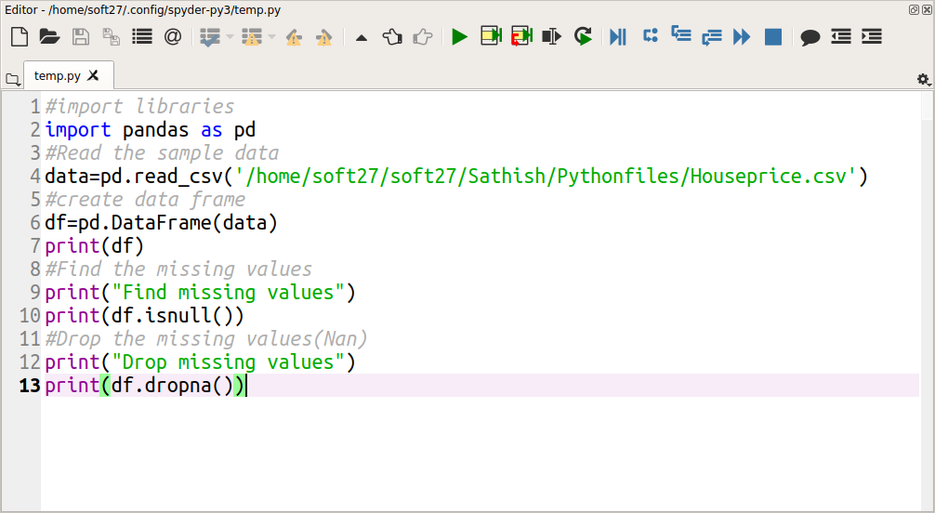

**Output:**

